Version <1.0>

Revision History

|  |  |  |  |
| --- | --- | --- | --- |
| **Date** | **Version** | **Description** | **Author** |
| <dd/mmm/yy> | <1.0> | <details> | Nguyen Kiem Hoa |
|  |  |  |  |
|  |  |  |  |
|  |  |  |  |

Table of Contents

1. Edit Image 4

1.1 Brief Description 4

1.2 Actor 4

2. Flow of Events 4

2.1 Basic Flow 4

3. Special Requirements 4

4. Preconditions 4

5. Postconditions 4

6. Extension Points 5

# Edit Image

## Brief Description

This use case defines the steps of editing an image which user posted. User can easily edit their image as they want.

## Actor

User

# Flow of Events

## Basic Flow

User open the image which they posted and click edit button. A form for editing will appear, user can change the content of their post as they want except the image. The information will be update immediately after user click update button.

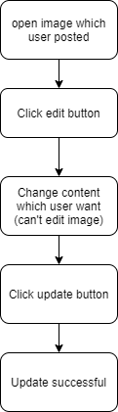

# Special Requirements

Click update button.

# Preconditions

Change content in the field.

# Postconditions

All content of image which was changed are updated.

# Extension Points

No extension point.